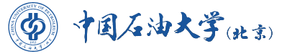
China University of Petroleum-Beijing

Bachelor’s Degree Diploma

June 29th, 2020
This is to certify that Mr./Ms. ZHANG Wenming, born on Jan. 18, 1982, has completed a four-year undergraduate program of study in Information management & Information Systems. He/She has fulfilled in full the requirements for a bachelor’s degree at China University of Petroleum-Beijing, and is hereby awarded the Bachelor’s Degree in Administration, in accordance with the Constitution of China University of Petroleum-Beijing.
Certificate No.1040000000000000

President
Chairman of the Academic Degree Evaluation Committee

